Q1 | Install the sqlite3 module in Python and write a script to create a new database called foodie.db with a table Restaurants (id, name, cuisine, rating).
Code | import sqlite3  # Connect to SQLite database  conn = sqlite3.connect("foodie.db")  # Create a cursor  cursor = conn.cursor()  # Create Restaurants table  cursor.execute("""  CREATE TABLE IF NOT EXISTS Restaurants (  id INTEGER PRIMARY KEY,  name TEXT,  cuisine TEXT,  rating REAL  )  """)  # Save changes  conn.commit()  # Close connection  conn.close()  print("Database 'foodie.db' and table 'Restaurants' created successfully!")
Output

Q2 | Using sqlite3 in Python, insert three sample restaurants into the Restaurants table in foodie.db and write a query to fetch all restaurants with a rating above 4.0, then print their names.
Code | import sqlite3  # Connect to the database  conn = sqlite3.connect("foodie.db")  # Create cursor  cursor = conn.cursor()  # Insert sample records  cursor.execute("INSERT INTO Restaurants VALUES (1, 'Swagat', 'Gujarati', 4.5)")  cursor.execute("INSERT INTO Restaurants VALUES (2, 'Pizza Hub', 'Italian', 4.8)")  cursor.execute("INSERT INTO Restaurants VALUES (3, 'Food Express', 'Chinese', 3.9)")  # Save changes  conn.commit()  # Fetch restaurants with rating greater than 4.0  cursor.execute("SELECT name FROM Restaurants WHERE rating > 4.0")  # Display restaurant names  rows = cursor.fetchall()  print("Restaurants with Rating Above 4.0:")  for row in rows:  print(row[0])  # Close connection  conn.close()
Output | 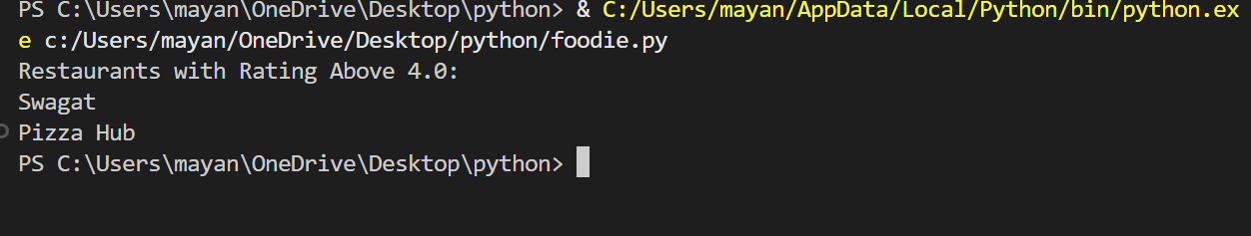

Q3 | Write Python code to load all rows from the Restaurants table in foodie.db into a Pandas DataFrame and display the top 2 rows using DataFrame.head().
Code | import sqlite3  import pandas as pd  # Connect to the database  conn = sqlite3.connect("foodie.db")  # Load data into a Pandas DataFrame  df = pd.read_sql_query("SELECT * FROM Restaurants", conn)  # Display the first 2 rows  print(df.head(2))  # Close the connection  conn.close()
Output | 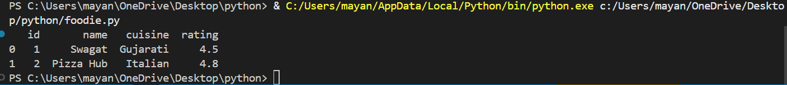

Q4 | Add a new column 'delivery_charge' to your DataFrame, setting it to 50 for all restaurants, and then calculate a new column 'final_rating' as rating + (0.1 if cuisine is 'Italian').<br><br><em><strong>Hint:</strong> Use DataFrame.apply() or a lambda function for the conditional logic.</em>
Code | import sqlite3  import pandas as pd  # Connect to the database  conn = sqlite3.connect("foodie.db")  # Load data into a DataFrame  df = pd.read_sql_query("SELECT * FROM Restaurants", conn)  # Add delivery_charge column  df["delivery_charge"] = 50  # Add final_rating column  df["final_rating"] = df.apply(  lambda x: x["rating"] + 0.1 if x["cuisine"] == "Italian" else x["rating"],  axis=1  )  # Display the updated DataFrame  print(df)  # Close the connection  conn.close()
Output | 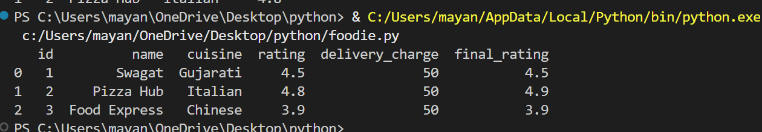

Q5 | Automate a daily summary: Write a Python script that connects to foodie.db, fetches all restaurants with rating above 4.5, loads them into a DataFrame, and saves the result as a CSV file named top_rated_restaurants.csv.
Code | import sqlite3  import pandas as pd  # Connect to the database  conn = sqlite3.connect("foodie.db")  # SQL query  query = "SELECT * FROM Restaurants WHERE rating > 4.5"  # Load data into DataFrame  df = pd.read_sql_query(query, conn)  # Save DataFrame as CSV file  df.to_csv("top_rated_restaurants.csv", index=False)  print("CSV file 'top_rated_restaurants.csv' created successfully.")  # Display the DataFrame  print(df)  # Close the database connection  conn.close()
Output | 